**SEO_MART Database Structure**

**Turning 5**

**BRD- Draft**

(Internal)

Table of Contents

1 Project Summary 3

1.1 Project Statement 3

2 Introduction 3

2.1 Overview 3

2.2 High Level Process 3

2.3 Scope 5

2.4 Column Requirements 7

2.5 Stakeholders 17

3 Assumptions, Dependencies & Constraints 18

3.1 Assumptions 18

3.2 Dependencies 18

3.3 Constraints 18

4 Important Links and Documents 19

4.1 Introduction 19

4.2 Functional Requirements 29

5 Document Control 35

5.1 Revision History 35

5.2 Reviewers (to date) 35

# Project Summary

## Project Statement

The purpose of the SEO_MART database redevelopment project is to develop a transparent, flexible and streamlined reporting environment to support the SEO Reporting and Analytics team in reporting and analyzing data involving students with disabilities.

# Introduction

The Turning 5 case process identifies where eligible Turning 5 (T5) students should be assigned. T5 students (based on their priority level), can either be assigned to a School Based Support Team (SBST) or Committee on Special Education (CPSE).

Each year, the Central Turning 5 team assigns eligible preschoolers with disabilities to a Turning 5 IEP team (school-based or CSE) to evaluate the students for school-age eligibility for special education services.

This case assignment process is based on several factors such as the student’s home address, the capacity of the IEP team, whether the student has a sibling that has already been assigned to an IEP team, or the student’s pre-k location.

In order to assign Turning 5 cases, the Central Turning 5 team collaborates with SEO’s data team to run the weekly case assignment process, which includes identification of which students should be classified as Turning 5 students and their assignment to a school-based or CSE IEP team. The data team also generates several weekly reports that:

* Open T5 referrals in SESIS (wave file) for students centrally assigned each week
* Update biographical data in SESIS based on information that is updated in CAP (biog file)
* Track status of Turning 5 cases (T5 tracking reports and T5 Referrals Power BI Report)
* Flag address issues preventing case assignment (invalid address report)
* Flag issues preventing opening of referral in SESIS (missing from SESIS report)
* Flag previously assigned students that are no longer eligible (ineligibility report)

Timeline:

Turning 5 case assignment generally begins in mid-December (before Christmas break) and continues on a weekly basis until the end of July.  The case assignment schedule for SY 20-21 is saved here. Typically, the majority of cases are assigned to school-based teams Beginning in May, CSE teams also open up initial referrals in SESIS for students who have never been previously evaluated by the CPSE.

## Overview

This Business Requirement Document specifies the following **SEO_MART** tables needed to support the Turning 5 process for SEO Reporting and Analytics:

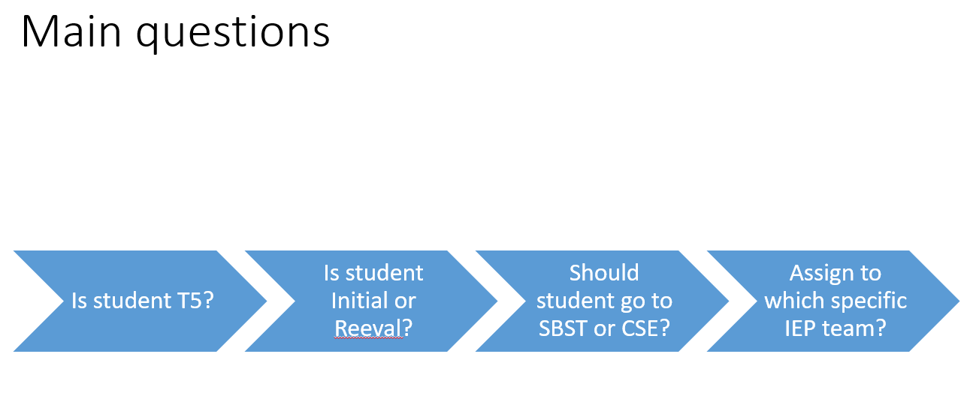

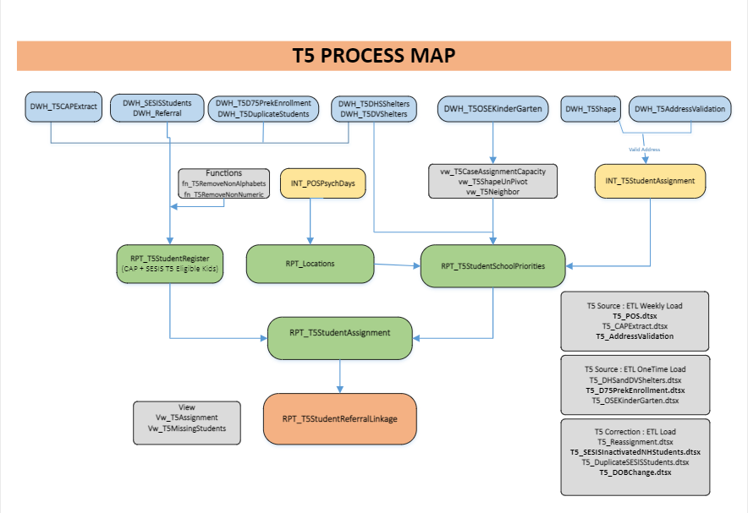

|  |  |  |  |
| --- | --- | --- | --- |
| Source Tables | Intermediate Tables | Report Tables | Views |
| **DWH_T5CAPExtract** | **INT_POSPsychDays** | **RPT_T5StudentRegister** | **vw_T5CaseAssignmentCapacity** |
| **DWH_T5AddressValidation** | **INT_T5StudentAssignment** | **RPT_Locations** | **vw_T5ShapeUnPivot** |
| **DWH_SESISStudents** | **INT_ATSStudents** | **RPT_T5StudentSchoolPriorities** | **vw_T5Neighbor** |
| **DWH_Referral** | **INT_T5Referral** | **RPT_T5StudentAssignment** | **Vw_T5Assignment** |
| **DWH_T5D75PrekEnrollment** | **INT_T5ReferralOutcome** | **RPT_T5ReferralLinkage** | **Vw_T5MissingStudents** |
| **DWH_T5DuplicateStudents** | **INT_T5ReferralOutcomePlace** | **RPT_T5ReferralLinkagePSE** |  |
| **DWH_T5DHSShelters** | **INT_T5ReferralOutcomePlacePSE** |  |  |
| **DWH_T5DVShelters** | **INT_T5ReferralOutcomePSE** |  |  |
| **DWH_T5OSEKinderGarten** |  |  |  |
| **DWH_T5Shape** |  |  |  |
| **DWH_T5SESISInactiveNHKids** |  |  |  |
| **DWH_T5DOBChange** |  |  |  |
| **DWH_T5Reassignment** |  |  |  |
| **DWH_T5DuplicateStudent** |  |  |  |

## High Level Process

**T5 Student Register Summary:** Turning 5 Requires new CAP extract every year, which is updated weekly. CAP file in addition to other source files (D75, DHS, DV Shelter) are all used to process the T5 Student Register table. We cannot start anything until the T5 Student register is completed with the following business rules:

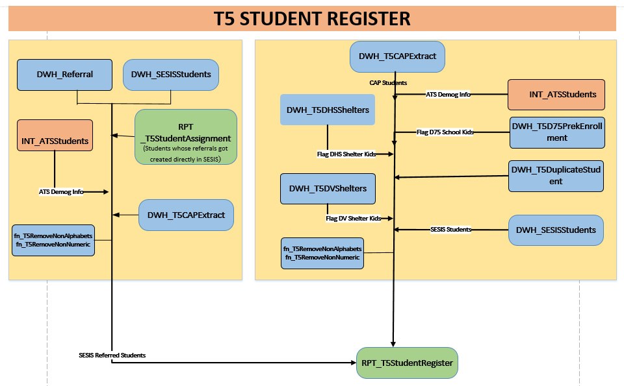

Identification of T5 students and Case Type

**Table: RPT_T5StudentRegister**

**DM Lead: Pangaj**

**CAP** **Business Rules:** This supports with identifying T5 students. Essentially, a student is eligible for a Turning 5 evaluation if he or she was born in the T5 school year and has been classified as a “preschooler with a disability”. If the student has moved out NYC, passed away, been declassified or if their parent has revoked consent, they are not assigned as a Turning 5 student.

The data team will query CAP and identify eligible Turning 5 students based on the business rules outlined below.

1. Student must have a Turning 5 date of birth (DOB) in CAP
2. Student must be classified as a preschooler with a disability or have a learning disability  (PreviousClassifCd is ‘PD’ or ‘LD’)
3. If a potential Turning 5 student has any of the data points listed below, they are **excluded** from central T5 case assignment.
   * 1. Program Recommendations (RecmProgram)
        1. Non-Handicapped (NH)
        2. Revocation of Consent (RC)
        3. General Education (GE)
     2. CAP discharge reasons ( CAPDischCd)
        1. Moved or Transferred from NYC (code 11)
        2. Deceased (code 15)
     3. CAP case closing code (CCReasonCd)
        1. Deceased (code 15)
        2. Moved out of NYC (code 65)
     4. Borough code (BoroCd)
        1. Y – outside of NYC within New York State
        2. Z – outside of NYC
     5. Home district (HomeDist)
        1. 88
        2. 98
        3. 99

The student’s case type (initial or reevaluation) is also set during the wave process. In general, if a Turning 5 student has a value in the consent for services field in CAP, he/she is considered a reevaluation or “reeval”.  Case type (process stage) for eligible T5 students is based on logic listed below, already included as part of the case assignment code:

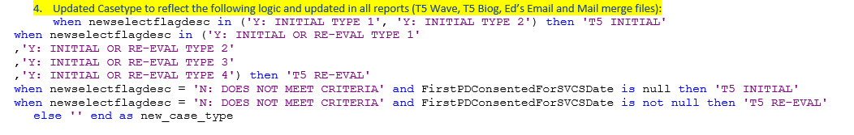

Determining where students will be assigned

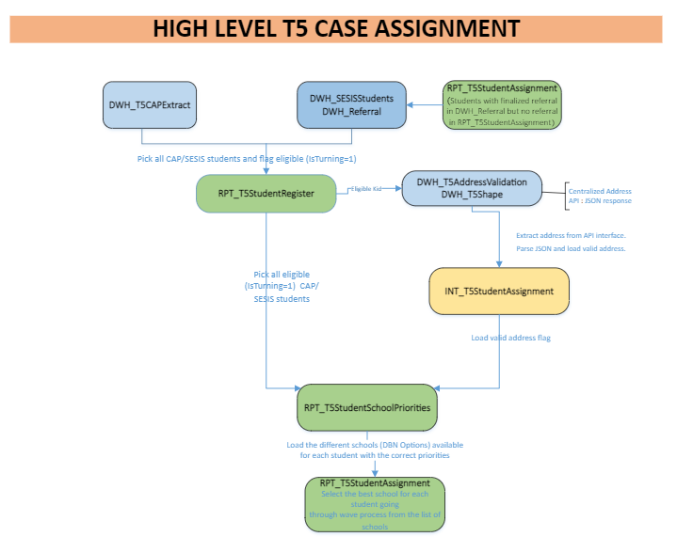

**T5 Case Assignment Summary:** Case assignments will consist of utilizing LCGMS, POS file, Shapefile, T5 Student Priorities, Wave process and T5 Referrals. The T5 student register is associated with the waves as it has the wave information in it. Once Turning 5 students are identified, students are assigned to a school-based or CSE based IEP team. The assignment to an IEP team will depend on various factors that will be discussed in this document.

**T5 team types :** There are two basic T5 team types that students can be assigned to: CSE or school-based IEP teams. In general, most T5 students are assigned to a school-based team and fewer students are assigned to a CSE team:

* There are 10 regional CSEs. Assignment to a CSE is based on home district at the time of assignment. Students can be assigned to CSE teams for the following reasons:
  + Students attend non-public schools that serve students with severe disabilities (bottom/top flag)
  + Student is attending a hospital school (null value in D75 pre-k file)
  + Overflow (school-based capacity has been exhausted based on pattern of service “POS” file)
* School IEP teams receive all T5 cases that do not meet the CSE criteria above. As mentioned previously, this represents the majority of T5 case assignments. At a high level, there are two different types of schools that can receive case assignments: elementary and middle schools. For algorithm, reporting and tracking purposes, these two categories are broken down further into the different school types.

**Table: RPT_T5StudentAssignment**

**DM Lead:** Pangaj

**Case Assignments to School and CSE teams Business Rules:**

Throughout the Turning 5 cycle, students are centrally assigned to CSE teams for the following reasons:

1. Eligible T5 students attend non-public schools that serve students with severe disabilities.
   1. The list of **“bottom/top”** non-public schools are listed below. If an eligible T5 student has any of the below values in the “CurrentCAPServiceSch” field in CAP, he/she should automatically be assigned to the CSE corresponding to their home district.

|  |  |
| --- | --- |
| CurrentCAPServiceSch | ServiceSchName |
| Y98C153 | JOHN A COLEMAN SCHOOL |
| K22C009 | AUDITORY/ORAL SCHOOL OF NYF NY |
| Q26C564 | ST. MARY'S HOSPITAL |

1. Eligible T5 student is attending a D75 hospital school (null value in D75 pre-k file)
   1. If a student is in the D75 pre-k file and there is a null or blank value in the “SchoolDBN” field, he/she is attending a hospital school and should automatically be assigned to the CSE corresponding to the child’s home district.
2. Overflow
   1. Once capacity has been exhausted at all available school options for a student, the overflow (student) should be assigned to the CSE corresponding to the child’s home district until CSE capacity has been exhausted (please reference SY21 CSE cap proposal in section 4.2.
3. All eligible T5 students assigned, should be assigned to the CSE team corresponding to the child’s home district and based on CSE capacity.
4. Initial Referral cases **opened directly in SESIS after May 1st**
   1. Please note that these cases are not centrally assigned. They are opened directly in SESIS by the CSE teams but these students should be **captured in T5 reporting**

**CSE Assignments**

**Wave 14-15:** From Wave 14 – Wave 15, the following T5 eligible students should be assigned to the CSE team that corresponds with his/her CAP home district:

1. Students who attend non-public schools on the bottom/top flag list.
2. Student is attending a D75 hospital school, indicated by null or blank value in the “School DBN” field of the D75 pre-k file)
3. Overflow – Once capacity at all school options for a particular student has been exhausted, that student should be assigned to the corresponding CSE if CSE capacity allows for this. Once CSE capacity has also been reached, then the unassigned students will be provided to the CSE /T5 team to get processed through the reassignement process based on CSE’s input.
4. From Wave 14 – Wave 15 *all* eligible T5 students were assigned to CSE teams if CSE capacity allows for this. In SY21, the WAVES were condensed to 15 WAVEs versus the 30 in past years.

**School Based Teams (SBST) Assignments:** Students who do not attend bottom/top schools or D75 hospital schools should be centrally assigned to school-based teams, unless there is no available capacity at any of the student’s available school options or they are identified and scheduled for assignment after wave 13.

**Wave 1-13:** From wave 1- wave 13, school-based teams should receive the majority of the case assignments. Only students attending bottom/top flag schools, D75 hospital schools and overflow should be centrally assigned to the corresponding CSE location. For SY21, Middle schools were only assigned during the first wave and then transfers of middle school cases to elementary school cases were handled by T5 team through the reassignment process. In SY21, from wave 14 – wave 15, no Turning 5 cases were assigned to school-based IEP teams (with the exception of ASL CAP students).

Determining school capacity

DM lead: K’lila

**T5 Capacity Summary:** Assignment to school-based teams is partially driven by the POS file. This POS file contains capacity information for school-based IEP teams that is used to identify how many Turning 5 cases the school-based teams can handle. Once capacity is exhausted at one school, the algorithm tries to find another school with available capacity. Once capacity is exhausted at all potential school options for one student, the student will be assigned to a CSE team as “overflow”.

Pattern of Service (POS) file*: R:\All Central Offices\CFN Contact Database\SEO\Clustering – additional access will need to be requested from Dan Simoes team*

The POS file includes many fields managed by Purvi and Maria. Purvi refreshes this file every Friday and notifies Maria to upload the updated version to the central R folder. Below are the fields that are used by the data team for the case assignment process. This file is shared yearly with the data team. Ideally, the data in the file is updated several times of year.

* SchoolDBN
* School Psychologist name
* Supervisor of Psychology name
* Supervisor of Psychology DOE email address
* # of days (psychologists)

POS rules

* Total students capacity at a school is calculated as sum of psych days at the school *7
* Vacancy and On-Call (OC) rows excluded
* Co-located and Null location rows in POS are excluded
* K-12 schools included (no assignments to schools listed as HS)

Business Rules for Middle School:

* Total students capacity at a Middle School is calculated as sum of psych days at the school *7
* Middle schools will be assigned a *maximum* of 5 cases each (originally was 7)
* Middle schools will complete assessments only and will transfer case to ES for conferencing (IEP meeting)
* Middle schools will only be assigned cases during the first wave
* During the first wave middle schools will have highest priority (before zoned schools)

Identification of partnership schools

* Partnership schools are elementary schools to which middle schools will transfer their T5 cases. This transfer happens after assessments have been concluded and the case is ready for the IEP meeting. This transfer happens outside of the central assignment process. Partnership schools are identified by their proximity to the student’s home, and are typically the student’s zoned elementary school or their closest choice school (in districts 1, 7, and 23). When a case is assigned to a middle school the partnership school has to be identified for two reasons:
* To create clear understanding to which ES the MS will transfer the case.
* To reduce available capacity at the partnership school to allow for enough capacity down the line to complete the transferred case.

Capacity for Partnership schools

* Turning 5 team handled the reassignment of transfer cases to elementary schools
* Middle schools were only assigned during WAVE 1 and then their capacity was zero’d out
* Turning 5 team indicates transfer cases to elementary schools in out reassignment files which they provided by EOD Fridays and data team processes it before assignment process on Monday mornings
* Turning 5 team utilizes the capacity view to project which elementary schools they should reassign cases to.

Capacity management for partnership schools

* Partnership schools will need capacity to take over the MS cases that they will be receiving later during the T5 season. Per the Supervisors of Psychologists Office two transferred MS cases equal one full case (i.e. two IEP meetings equal one full case). Therefore, during the first wave when cases are assigned to middle schools, the capacity for partnership schools will be reduced as follows:
* Student A is assigned to MS #1 [reduce available capacity of MS #1 by 1; reduce available capacity of zoned ES for student A by 0.5]
* Student B is assigned to MS #1 [reduce available capacity of MS #1 by 1; reduce available capacity of zoned ES for student B by 0.5]
* Etc. until MS #1 has reached full caseload (7 cases per day of service with a max of 7 cases per MS).
* Notes:
  + Zoned ES for student A and student B may be different even though they are assigned to same MS.
  + For choice districts the partnership school will be the nearest ES/choice school to the student’s home address.
  + This is a new process. In previous years we did not reduce available capacity for partnership schools.

Determining student priority

**Student Priority and School Option Summary:** Case assignment is also partially driven by many student-level factors including student pre-k location, whether the student has a sibling who is also eligible for the Turning 5 process and whether the student is in temporary housing, etc. These factors and policy decisions about these factors determine the order  (priority) that a student will go through the case assignment process.  Eligible T5 students should be prioritized in the case assignment algorithm per priorities set below. Below is the list of case assignment priorities (order through which student goes through the case assignment algorithm) that was used for the SY 20-21 case assignment cycle.

Table: **T5_StudentSchoolPriorities**

Business Rules:

1. Bottom/top flag (assigned to CSE team)
   1. If a student is attending certain non-public school programs that serve children with severe disabilities, the student will automatically be assigned to the CSE that corresponds to the child’s home district. These types of assignments are indicated by the “bottom/top flag”. Students with a bottom/top flag are given the highest priority in the case assignment algorithm.

|  |  |
| --- | --- |
| CurrentCAPServiceSch | ServiceSchName |
| Y98C153 | JOHN A COLEMAN SCHOOL |
| K22C009 | AUDITORY/ORAL SCHOOL OF NYF NY |
| Q26C564 | ST. MARY'S HOSPITAL |

1. Students attending American Sign Language school (02M347) (assigned to 02M347 irrespective of case capacity)
   1. Our code is doing a case when statement where 02M047 à 02M347 because it is the HS ASL school so they are reassigned to the K-8 02M347
   2. Students enrolled at 02M347 (American Sign Language school) for preschool should be assigned to the IEP team at 02M347 regardless of case capacity. This policy decision was made so that families are able to communicate with clinicians who know ASL.
2. Students in temporary housing assigned to zoned school (if there is available capacity)
   1. In SY21 we collaborated with the Office of Student Enrollment to prioritize this population and assign students in temporary housing during the first wave of case assignment.
   2. The DHSDVFlag was updated on 4/29/2021 to include 31 new students who were identified in the April 2021 T5 Shelter file. The flag was updated in RPT_T5StudentRegister and RPT_T5ReferralLinkage. This update will allow the 31 new shelter students to flow down into T5 dashboard beginning on 4/29/2021.IEP and Placement Compliance Deadlines
3. Students currently enrolled in a D75 location assigned to same D75 site (if there is available capacity)
   1. Each November, the D75 office provides the data team with a list of pre-k students currently enrolled at a D75 site. This list is used by the data team in order to try to assign students to their D75 pre-k location.  Students attending a D75 Pre-K site are assigned to the D75 site for their T5 evaluation. Since these students have a very high priority in the algorithm, most students that are attending a D75 pre-k site will be assigned to that site. Some exceptions include when the D75 school is not listed in the POS file, has a psychologist vacancy or is at capacity.  In some cases, students on the D75 file do not have a D75 school listed in the file (field is blank). Per the D75 office, this null value indicates that the student is attending a hospital school. In SY 18-19, we decided that these students should have their cases assigned to the corresponding CSE to align with the policy of assigning students who attend hospital schools to an accessible CSE location.
4. Students currently enrolled in a D1-32 pre-k location (excludes 02M347) are assigned to that same D1-32 pre-k location (if there is available case capacity)
   1. To the extent possible, Turning 5 students are assigned to an IEP team at their pre-k location. This was a policy decision put in place prior to 2017. The intent was to minimize the family’s need to travel to another site for evaluation and to also allow the IEP team at the child’s current school to evaluate the student. This decision affects preschool students enrolled in D75 or D1-32 pre-k sites.
5. Students without valid address assigned to zip code school (if there is available case capacity)
   1. Zip code school is determined by match in zip code and match in district between school location and student’s home address in CAP
   2. There are several invalid address issues that can affect whether we are able to assign a student’s Turning 5 case in a particular week. If we are unable to assign a student’s case due to an invalid address issue, the student will appear on the invalid address report each week until the particular address issue has been resolved. In order to resolve an invalid address issue, the CPSE has to reach out to the family and confirm that the address for the student is correct. If the address is not correct, the address should be corrected in CAP to avoid future issues.
   3. To address invalid address issues, in SY18-19, we created a new way of assigning students based on their zip codes. In cases where a student had an invalid address, the data team used the student’s zip code and home district to identify a nearby school. If the school zip code matched the zip code of the student’s address and was located in the student’s home district, the student was assigned to that school if there was capacity at that school. This method allowed us to reduce the number of students who we were unable to assign because of address issues. This method also allowed us to assign students sooner in the case assignment process.
6. Middle school [WAVE 1 ONLY; Middle schools will *not* receive assignments in Waves 2-15]
7. Zoned school
   1. Students who have zoned schools should be assigned to their zoned school until POS capacity is exhausted. As mentioned previously, siblings should also be assigned to the same school to prevent the family from having to go to more than one site for evaluation. Cases should be distributed equitably in cases of shared zones.  Most Turning 5 students are assigned to their zoned schools as a student is most likely to receive an offer to their zoned school through the kindergarten admissions process. Although we attempt to assign students to their zoned schools, we are not always able to assign students to that school.
8. CSE Assignments
   1. This movement for CSE up to a higher priority was decided in SY21 based on CSE feedback to exhaust capacity earlier in the WAVEs
9. Choice school
   1. If the algorithm has determined that there is no available space at a zone school or middle school, the algorithm will look for a choice school to assign a student to. Students in a choice district can be assigned to any school in their district that has available case capacity.
10. Non-zoned school
    1. Once the algorithm has exhausted zoned, middle school, choice school options, it will look to slot a student in a non-zoned school with available capacity.
11. Neighbor school
    1. Once the algorithm has exhausted zoned, middle school, choice school, non-zoned, it will look to slot a student in a neighbor school with available capacity.
12. Gifted & Talented schools
    1. Once the algorithm has exhausted zoned, middle school, choice school, non-zoned and G&T options, it will look to slot a student in a gifted & talented school with available capacity.
13. Other schools
14. Overflow (CSE): Once capacity has been exhausted for options 7-13, remainder of eligible T5 students should be assigned to the CSE location corresponding with their CAP home district.

In addition to the listed priorities listed above, siblings are also prioritized in the case assignment algorithm. If a T5 eligible student is a sibling of another T5 student that is also being assigned through the case assignment process, we attempt to assign the siblings to the same IEP team. For example, if a student has a bottom/top flag, siblings of that student would also be assigned to the same CSE team. Students who have been assigned because they are siblings will have the “sibling flag” in T5 reports.

The data team uses the following data points to identify siblings:

* GuardianLastName
* GuardianFirstName
* Zip Code

Determining Turning 5 Referral Linkage:

This process links Referral, Consent, Assessment and Outcome documents based on set of business rules designed around ReferralDate, ConsentDate, AssessmentDate and OutcomeDate columns:

**ReferralDate <= ConsentDate <= AssessmentDate <= OutcomeDate <= PlacementDate**

**Consideration/Definition for referrals reporting to understand case movement/status/timeliness:**

1. **Referral Types in T5 Referral Linkage:**T5 INITIAL and T5 RE-EVAL
2. **Compliance**: From may 11th through August 31st INITIAL Referrals received will have IEP and PWN compliance days 60 schools days from date of consent. Therefore, referrals with no consent will not have a calculated compliance date attached to the referral.

|  |  |
| --- | --- |
| **If a request for a reevaluation is received…** | **…the evaluation must be completed by:** |
| From September 1**st** through March 1st | June 1 |
| From March 2**nd** through April 1**st** | July 1 |
| From April 2nd through May 10th | August 2 |
| From May 11**th** through August 31st | 60 school days from the date of the referral |

|  |  |
| --- | --- |
| **If a referral is received…** | **…placement must be offered by:** |
| From September 1**st** through March 1st | June 15 |
| From March 2**nd** through April 1**st** | July 15 |
| From  April 2nd through May 10th | August 15 |
| From May 11**th** through August 31st | 60 school days from the date of the referral |

1. **Outcome types for T5 referrals:**
2. **IEP** -The IEP meeting has taken place and student has been classified as a student with a disability Outcomes of IEP,
3. **IESP** - The IEP meeting has taken place and student has been classified as a student with a disability Outcomes of IESP
4. **Inligible** – for Initial Referrals, the IEP meeting has taken place and student has been found ineligible for an IEP
5. **Declass** – For reevaluation referrals, the IEP meeting has taken place and student has been declassified as a student with a disability
6. **Caseclose** - The case has been closed without an IEP meeting.
7. **Discharge** - The case has been Discharged without an IEP meeting
8. **Open/Awaiting**- outcome is not available for the referral

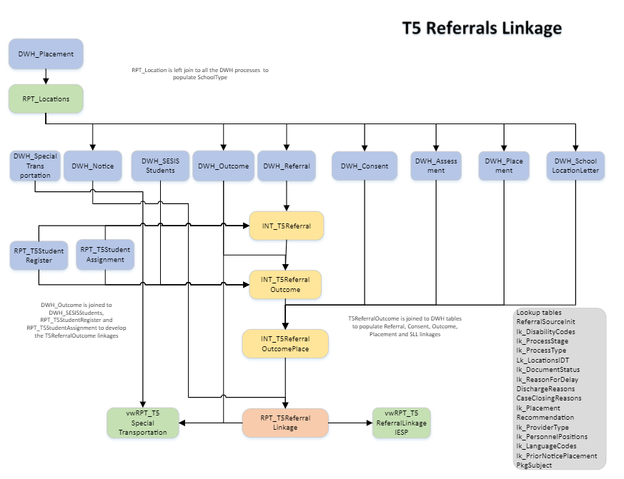

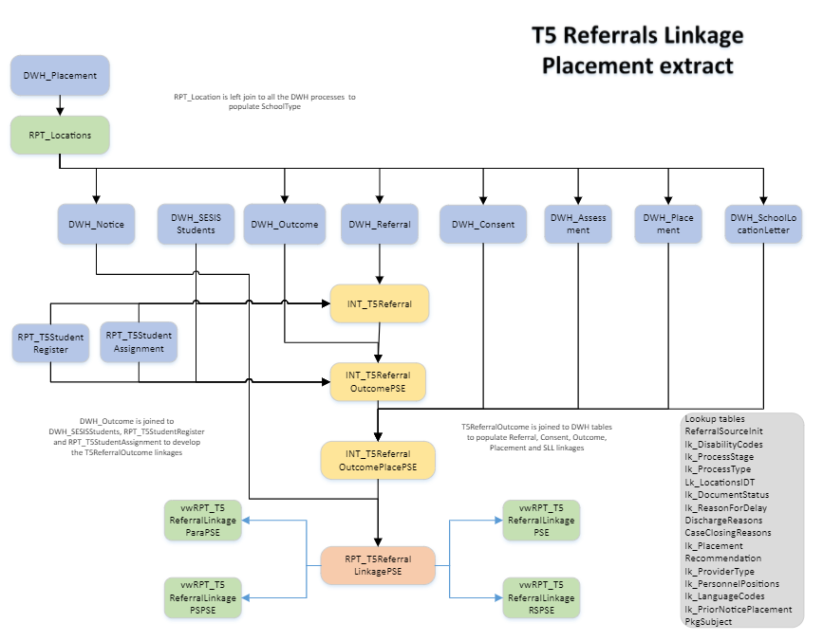

## Scope

This section clarifies the scope of the requirements with reference to the scope of the overall project

### In Scope

The following parameters are in scope for Turning 5 case assignment.

The following table outlines the necessary T5 source files, which helps with identifying a students priority. The source files were obtained by the following owners listed and was coordinated through Maria Gullo on the Turning 5 team.

|  |  |  |  |  |
| --- | --- | --- | --- | --- |
| File | R Drive Location | Column Required | Processing Step | Owner |
| D75PrekEnrollment | \\CENTRAL.NYCED.ORG\DoE$\SEO Analytics\Share\Turning 5\SourceFiles\D75 PreK Enrollment | |  | | --- | | SchoolDBN | | site | | studentid | | |  | | --- | | SP T5_StudentRegisterLOAD | | SP T5_StudentRegisterLOAD | | SP T5_StudentRegisterLOAD | | Pratricia K (PKlebanov@schools.nyc.gov) |
| DHSShelters | \\CENTRAL.NYCED.ORG\DoE$\SEO Analytics\Share\Turning 5\SourceFiles\ShelterFile | OSISID  ZoneSchool(1-5) | SP T5_StudentRegisterLOAD  SP T5_StudentSchoolPrioritiesLOAD | Brielle McDaniel (BMcdaniel@schools.nyc.gov) |
| DVShelters | \\CENTRAL.NYCED.ORG\DoE$\SEO Analytics\Share\Turning 5\SourceFiles\ShelterFile | NYCID  ZonedSchool | SP T5_StudentRegisterLOAD  SP T5_StudentSchoolPrioritiesLOAD | Brielle McDaniel (BMcdaniel@schools.nyc.gov) |
| OSEkindergarten | \\CENTRAL.NYCED.ORG\DoE$\SEO Analytics\Share\Turning 5\SourceFiles\OSE Kindergarten | |  | | --- | | schooldbn | | schooltype | | |  | | --- | | SP T5_StudentSchoolPrioritiesLOAD | | SP T5_StudentSchoolPrioritiesLOAD | | Brielle McDaniel (BMcdaniel@schools.nyc.gov) |
| Shapefiles Current School Year | \\CENTRAL.NYCED.ORG\DoE$\SEO Analytics\Share\Turning 5\SourceFiles\ShapeFile | ID | SP T5_StudentSchoolPrioritiesLOAD | Jonathan Geis (JGeis2@schools.nyc.gov) |
| POS | R:\All Central Offices\CFN Contact Database\SEO\Clustering | Geodistrict  Posdbn  Locationtype  Lookupid  zipcode | SP T5_StudentSchoolPrioritiesLOAD | Daniel Simoes (DSimoes@schools.nyc.gov)  Purvi Dharia (PDharia@schools.nyc.gov) |
| CAP | \\CENTRAL.NYCED.ORG\DoE$\SEO Analytics\Share\Turning 5\SourceFiles\T5 CAP Extract | NYCID  HomeDist  AssignedLocationForTracking  AssignedLocationSource  CaseStatus  CaseProgress  EvalType  EvalDesc  RefDate  ReferSch  ConsentDate  CurrentCAPServiceSch  ServiceSchName  AssessmentBilLangCd  CCDate  CCReasonCd  CCDesc  EvalComplianceDate  PlacementComplianceDate  CAPDischDate  CAPDischCd  HomeDist  StudentLastName  StudentFirstName  StudentDOB  StudentGender  IEPConfDate  RecmProgram  DualRecmInd  StudParticipateInTestingFl  EPCCOHPromotionCd  OLDSelectFlag  OLDSelectFlagDesc  NEWSelectFlag  NEWSelectFlagDesc  RecmServCat  12MonthInd  ClsCd  PreviousClassifCd  SEITSessionsPerWk  RecmRS  FinalNoticeDate  FinalNoticeConsentDate  AuthDate  FirstAttendDate  NextMostRecentFAD  Site  SiteClassNumber  ZonedSchool  ZONEDSchoolForLCGMS  AssignedDBN  HouseNumber  Street  BoroCd  ZipCd  AptNumber  CityName  GuardianLastName  GuardianFirstName  GuardianPhoneNo  GuardianLanguage  CSE  SchCluster  ClusterLeader  SchNetwork  NetworkLeader  Phase1Ind  FirstTimeFlag  FirstTimeDate  AlreadyAssigned  RunDate  SiteOfferCTR  FNRStatus  LocationGroup  ComplianceGroup  CAPCompletionStatus  FirstPDConfDate  FirstPDConsentedForSVCSDate  ProcessedDate  RecmProgram | SP T5_StudentRegisterLOAD | Jerry Piper  (GPiper2@schools.nyc.gov) |

### Out of Scope

The following provides clarification of specific items that are **not within the scope** of this project.

## Column Requirements

**T5 Student Register**

1. Pick all the students after May 1st of school year, satisfying following conditions and directly created in SESIS (Use DWH_SESISStudents). Below were the rules for student whose referrals are opened in SESIS but not in CAP.
2. Students with finalized referral in DWH_Referral but no referral in RPT_T5Referral
3. Students with Turning 5 birth year
4. Pick all the students from T5_CAPExtract CAP file.

**Rules for the main calculated column:**

1. SESISFlag is set to N if the following are true:
2. The student is NOT present in DWH_SESISStudents
3. The student is NOT a deleted student

1. Top Flag and Bottom Flag is set only when CAP School is 'K22C009', 'Q26C564', 'Y98C153'

1. Students are T5 eligible if the following is true. IsTurning5 is set for T5 eligible students. Not all eligible students will go through the wave process. Check T5ProcessFlag for more details.
2. If the PreviousClassifCode is ‘PD’ or ‘LD’ -  nulls excluded
3. If the RecmProgram is NOT ‘NH’ or ‘RC’ or ‘GE’ - null included
4. If the CAPDischCode is NOT either 15 or 11- nulls included
5. If CCReasonCode is NOT either 15 or 65 - nulls included
6. If BoroughCode is not ‘Y’ or ‘Z’ nulls included
7. If HomeDistrict is not either 88 or 98 or 99 - nulls included

1. BiogReportFlag is set to Y if the following condition is true:
2. If the current run’s biog are not same as the previous run’s biog data
3. If the BoroughCode is not ‘Y’ or ‘Z’
4. If the Home district is not 88,98,99

BiogReportFlag indicates the list of wave students in biog report. Not all wave new student will be in biog report. Only student with t5processflag=’y’ (valid address or any DBN options) should be in biog report.

1. DHSDVFlag
2. It is set to DHS if the student is present in **DWH**_**T5DHSShelters**
3. It is set to DV if the student is present in **DWH_T5DVShelters**

1. D75Flag
2. It is set to Y if the student is present in **DWH_T5D75PrekEnrollment**

1. D75PhysicalDBN
2. It is set with the school **in DWH_T5D75PrekEnrollment**

1. ValidAddressFlag

This column is loaded in **T5_StudentSchoolPrioritiesLOAD** because we need to know the DBN options and the address validation result.

1. It is set to YY when the student has a proper address after validating with NYC address API. These students will go through the wave process
2. It is set to NY when the Students fail the address check but have other DBN options like ATS Prek, DHS/DV, D75, ZipCd schools. These students will go through the wave process. If a student can be assigned to a choice school, neighbour school, etc they should not be included in the invalid address file.
3. It is set to NN when the Students fail the address check and do not have other DBN options like ATS Prek, DHS/DV, D75, ZipCd schools. These students will NOT go through the wave process but added to the invalid address file. This file is only for student who cannot be assigned to the zoned school, choice school, neighbour school, etc due to an address issue.
4. BestT5PriorityCode and BestT5PriorityDesc

This column is loaded in **T5_StudentSchoolPrioritiesLOAD** because we need to know all the DBN options and find the best option available for each student.

1. T5ProcessFlag

This column is loaded in **T5_StudentSchoolPrioritiesLOAD** because we need to know all the DBN options before we decide if the student is actually eligible for wave process.

If the student does not have a valid address nor any DBN options, the T5ProcessFlag will be ‘N’. These students will not go through the wave process in the current week.

**Table Name: RPT_T5StudentRegister ([SEO_MART].[dbo].[RPT_T5StudentRegister])**

|  |  |  |  |
| --- | --- | --- | --- |
| Student Register Column | CAP Source Table | CAP Source Column/Logic | Next Steps |
| [StudentID] | DWH_T5CAPExtract | NYCID |  |
| [CaseType] | Calculated | CASE  WHEN cap.NewSelectFlagDesc IN  ( 'Y: INITIAL TYPE 1', 'Y: INITIAL TYPE 2')  THEN 'T5 INITIAL'  WHEN cap.NewSelectFlagDesc IN  ( 'Y: INITIAL OR RE-EVAL TYPE 1',  'Y: INITIAL OR RE-EVAL TYPE 2',  'Y: INITIAL OR RE-EVAL TYPE 3',  'Y: INITIAL OR RE-EVAL TYPE 4')  THEN 'T5 RE-EVAL'  WHEN cap.NewSelectFlagDesc = 'N: DOES NOT MEET CRITERIA'  AND FirstPDConsentedForSVCSDate =0  THEN 'T5 INITIAL'  WHEN cap.NewSelectFlagDesc = 'N: DOES NOT MEET CRITERIA'  AND FirstPDConsentedForSVCSDate IS NOT NULL THEN 'T5 RE-EVAL'  ELSE NULL  END AS casetype |  |
| [SchoolYear] |  | 2020-2021 |  |
| [AssignedLocationForTracking] | DWH_T5CAPExtract | AssignedLocationForTracking |  |
| [AssignedLocationSource] | DWH_T5CAPExtract | AssignedLocationSource |  |
| [CaseStatus] | DWH_T5CAPExtract | CaseStatus |  |
| [CaseProgress] | DWH_T5CAPExtract | CaseProgress |  |
| [EvaluationType] | DWH_T5CAPExtract | [EvalType] |  |
| [EvaluationDesc] | DWH_T5CAPExtract | [EvalDesc] |  |
| [ReferralDate] | DWH_T5CAPExtract | [ReferralDate] |  |
| [ReferralSchool] | DWH_T5CAPExtract | [ReferralSchool] |  |
| [ConsentDate] | DWH_T5CAPExtract | [ConsentDate] |  |
| [CurrentCAPServiceSchool] | DWH_T5CAPExtract | [CurrentCAPServiceSchool] |  |
| [ServiceSchoolName] | DWH_T5CAPExtract | [ServiceSchoolName] |  |
| [AssessmentBilLangCode] | DWH_T5CAPExtract | [AssessmentBilLangCode] |  |
| [CaseCloseDate] | DWH_T5CAPExtract | [CCDate] |  |
| [CaseCloseReasonCode] | DWH_T5CAPExtract | [CCReasonCode] |  |
| [CaseCloseDesc] | DWH_T5CAPExtract | [CCDesc] |  |
| [EvaluationComplianceDate] | DWH_T5CAPExtract | [EvalComplianceDate] |  |
| [PlacementComplianceDate] | DWH_T5CAPExtract | [PlacementComplianceDate] |  |
| [CAPDischargeDate] | DWH_T5CAPExtract | [CAPDischargeDate] |  |
| [CAPDischargeCode] | DWH_T5CAPExtract | [CAPDischargeCode] |  |
| [HomeDistrict] | DWH_T5CAPExtract | [HomeDistrict]  Two digit number (01,02,03 …..31,32,88,98,99) |  |
| [LastName] | DWH_T5CAPExtract | StudentLastName | Rename? |
| [FirstName] | DWH_T5CAPExtract | StudentFirstName | Rename? |
| [BirthDate] | DWH_T5CAPExtract | [StudentDOB] | Rename? |
| [Gender] | DWH_T5CAPExtract | [StudentGender] | Rename? |
| [IEPConferenceDate] | DWH_T5CAPExtract | [IEPConfDate] |  |
| [RecommendedProgram] | DWH_T5CAPExtract | [RecmProgram] | Rename? |
| [DualRecmInd] | DWH_T5CAPExtract | [DualRecmInd] |  |
| [StudParticipateInTestingFlag] | DWH_T5CAPExtract | [StudParticipateInTestingFlag] |  |
| [EPCCOHPromotionCode] | DWH_T5CAPExtract | [EPCCOHPromotionCode] |  |
| [OldSelectFlag] | DWH_T5CAPExtract | [OldSelectFlag] | Delete |
| [OldSelectFlagDesc] | DWH_T5CAPExtract | [OldSelectFlagDesc] | Delete |
| [NewSelectFlag] | DWH_T5CAPExtract | [NewSelectFlag] | Rename? |
| [NewSelectFlagDesc] | DWH_T5CAPExtract | [NewSelectFlagDesc] | Rename? |
| [RecommServiceCategory] | DWH_T5CAPExtract | [RecmServCat] |  |
| [12MonthInd] | DWH_T5CAPExtract | [12MonthInd] |  |
| [ClassificationCode] | DWH_T5CAPExtract | [ClsCode] |  |
| [PreviousClassificationCode] | DWH_T5CAPExtract | [PreviousClassifCode] |  |
| [SEITSessionsPerWeek] | DWH_T5CAPExtract | [SEITSessionsPerWeek] |  |
| [RecommendedRS] | DWH_T5CAPExtract | [RecmRS] |  |
| [FinalNoticeDate] | DWH_T5CAPExtract | [FinalNoticeDate] |  |
| [FinalNoticeConsentDate] | DWH_T5CAPExtract | [FinalNoticeConsentDate] |  |
| [AuthDate] | DWH_T5CAPExtract | [AuthDate] |  |
| [FirstAttendDate] | DWH_T5CAPExtract | [FirstAttendDate] |  |
| [NextMostRecentFAD] | DWH_T5CAPExtract | [NextMostRecentFAD] |  |
| [Site] | DWH_T5CAPExtract | [Site] |  |
| [SiteClassNumber] | DWH_T5CAPExtract | [SiteClassNumber] |  |
| [ZonedSchool] | DWH_T5CAPExtract | [ZonedSchool] |  |
| [ZonedSchoolForLCGMS] | DWH_T5CAPExtract | [ZonedSchoolForLCGMS] |  |
| [AssignedDBN] | DWH_T5CAPExtract | [AssignedDBN] |  |
| [HouseNumber] | DWH_T5CAPExtract | [HouseNumber] |  |
| [Street] | DWH_T5CAPExtract | [Street] |  |
| [BoroughCode] | DWH_T5CAPExtract | [BoroughCode] |  |
| [ZipCode] | DWH_T5CAPExtract | [ZipCode] |  |
| [ApartmentNumber] | DWH_T5CAPExtract | [AptNumber] |  |
| [CityName] | DWH_T5CAPExtract | [CityName] | Remove Special character and No numerical value |
| [GuardianLastName] | DWH_T5CAPExtract | [GuardianLastName] |  |
| [GuardianFirstName] | DWH_T5CAPExtract | [GuardianFirstName] |  |
| [GuardianPhoneNumber] | DWH_T5CAPExtract | [GuardianPhoneNo] | Remove Special character. Only numerical value and length of phone number should be 10 are allowed.  Checking for 10 digits in phone numbers, else fill by blank value |
| [GuardianLanguage] | DWH_T5CAPExtract | [GuardianLanguage] |  |
| [CSE] | DWH_T5CAPExtract | [CSE] |  |
| [SchoolCluster] | DWH_T5CAPExtract | [SchCluster] | Delete |
| [ClusterLeader] | DWH_T5CAPExtract | [ClusterLeader] | Delete |
| [SchoolNetwork] | DWH_T5CAPExtract | [SchNetwork] | Delete |
| [NetworkLeader] | DWH_T5CAPExtract | [NetworkLeader] | Delete |
| [Phase1Ind] | DWH_T5CAPExtract | [Phase1Ind] |  |
| [FirstTimeFlag] | DWH_T5CAPExtract | [FirstTimeFlag] |  |
| [FirstTimeDate] | DWH_T5CAPExtract | [FirstTimeDate] |  |
| [AlreadyAssigned] | DWH_T5CAPExtract | [AlreadyAssigned] |  |
| [CAPRunDate] | DWH_T5CAPExtract | [RunDate] |  |
| [SiteOfferCTR] | DWH_T5CAPExtract | [SiteOfferCTR] |  |
| [FNRStatus] | DWH_T5CAPExtract | [FNRStatus] |  |
| [LocationGroup] | DWH_T5CAPExtract | [LocationGroup] |  |
| [ComplianceGroup] | DWH_T5CAPExtract | [ComplianceGroup] |  |
| [CAPCompletionStatus] | DWH_T5CAPExtract | [CAPCompletionStatus] |  |
| [FirstPDConfDate] | DWH_T5CAPExtract | [FirstPDConfDate] |  |
| [FirstPDConsentedForSVCSDate] | DWH_T5CAPExtract | [FirstPDConsentedForSVCSDate] |  |
| [IsNewT5] | Calculated | CASE  WHEN FirstPDConfDate < 20201001  AND CONVERT(VARCHAR(35), GETDATE(), 112) >= 20200326  AND CONVERT(VARCHAR(35), GETDATE(), 112)  < 20200401  THEN 1  WHEN FirstPDConfDate < 20200301  AND CONVERT(VARCHAR(35), GETDATE(), 112) >= 20200409  AND CONVERT(VARCHAR(35), GETDATE(), 112)  < 20200414  THEN 2  WHEN FirstPDConfDate >= 20200301  AND FirstPDConfDate < 20200401  AND CONVERT(VARCHAR(35), GETDATE(), 112) >= 20200514  AND CONVERT(VARCHAR(35), GETDATE(), 112)  < 20200519  THEN 3  WHEN FirstPDConfDate >= 20200401  AND FirstPDConfDate < 20200510  AND CONVERT(VARCHAR(35), GETDATE(), 112) >= 20200611  AND CONVERT(VARCHAR(35), GETDATE(), 112)  < 20200616  THEN 4  ELSE 0 END NewT5Flag |  |
| [SchoolDBN] | INT_ATSStudents | SchoolDBN |  |
| [IsTop] | Calculated | CASE  WHEN CurrentCAPServiceSchool IN  (‘K22C009', 'Q26C564')  AND RecmProgram = 'CP'  AND SUBSTRING(a.SchoolDBN, 1, 2) = '88'  THEN 1  ELSE 0  END TopFlag |  |
| [IsBottom] | Calculated | CASE  WHEN CurrentCAPServiceSchool IN  ('K22C009', 'Y98C153')  AND RecmProgram = 'CP'  AND a.SchoolDBN LIKE '88%'  THEN 1  ELSE 0  END BottomFlag |  |
| [NoNameStreetFlag] | Calculated | CASE  WHEN Street LIKE 'NO NAME'  OR Street LIKE 'NONAME'  THEN 1  ELSE 0  END NoNameStreetFlag |  |
| [IsSibling] | Calculated | CASE  WHEN SUM(CASE WHEN IsTurning5 = 'Y'  THEN 1 ELSE 0 END  )OVER(PARTITION BY GuardianLastName, GuardianFirstName, ZipCode) > 1  THEN 1  ELSE 0  END SiblingFlag | Renamed |
| [WaveProcessedDate] | Calculated |  |  |
| [CreatedDate] | Calculated | GETDATE() |  |
| [ModifiedDate] | Calculated | Last updated date. |  |
| [SchoolYear] | Calculated | Reporting school year 2020-202 |  |
| [T5RecordSource] | Calculated | CAP |  |
| [SelectFlag] | Calculated | 'Y' AS SelectFlag |  |
| [SelectFlagDate] | Calculated | Current date : GETDATE() |  |
| [D75AdminDBN] | DWH_T5D75PrekEnrollment | D75.SchoolDBN |  |
| [D75PhysicalDBN] | DWH_T5D75PrekEnrollment | D75.[Site] | Rename? |
| [CAPPrekSchool] | Calculated | CASE  WHEN D75.[Site] IS NULL  AND LEN(cap.CurrentCAPServiceSchool) = 7  AND cap.RecmProgram LIKE 'CP'  AND a.SchoolDBN LIKE '88%'  THEN  cap.CurrentCAPServiceSchool  ELSE NULL  END AS CAPPrekSchool |  |
| [IsPreK] | Calculated | CASE  WHEN a.GradeLevel = 'PK'  THEN 1  ELSE 0  END AS PreKFlag |  |
| [ATSPrekSchoolDBN] | Calculated | CASE  WHEN a.GradeLevel = 'PK'  THEN a.SchoolDBN  ELSE NULL  END AS ATSPrekSchDBN |  |
| [EvalIniConsentDate] | DWH_SESISStudents | CAST(s.DateEvalIniConsent AS DATE) AS DateEvalIniConsent |  |
| [IsTurning5] | Calculated | /***This is condition to pick CAP students for T5 wave processing/  CASE  WHEN ISNULL(PreviousClassificationCode, 'XYZXYZ') IN ( 'PD', 'LD' )  AND ISNULL(RecommProgram, 'XYZXYZ') NOT IN ( 'NH', 'RC', 'GE' )  AND ISNULL(CAPDischCode, 999999) NOT IN ( 15, 11 )  AND ISNULL(CCReasonCode, 999999) NOT IN ( 15, 65 )  AND ISNULL(BoroughCode, 'XYZXYZ') NOT IN ( 'Y', 'Z' )  AND ISNULL(HomeDistrict, 999999) NOT IN ( 88, 98, 99 )  THEN 'Y'  ELSE 'N'  END IsTurning5 | Renamed |
| [DHSDVFlag] | Calculated | -- T5_DHSShelters DHS  -- T5_DVShelters DV  CASE  WHEN DHS.OSISID IS NOT NULL  THEN 'DHS'  WHEN DV.NYCID IS NOT NULL  THEN 'DV'  ELSE NULL  END DHSDVFlag |  |
| [D75Flag] | Calculated | --T5_D75PrekEnrollment  CASE  WHEN D75.StudentID IS NOT NULL  THEN 'Y'  ELSE 'N'  END D75Flag |  |
| [SiblingKey] | Calculated | CONCAT(cap.GuardianLastName,cap.GuardianFirstName,  cap.ZipCode) AS SiblingKey | Renamed |
| [SESISFlag] | Calculated | CASE  WHEN s.StudentID IS NULL AND dup.OldStudentID IS NULL  THEN 'N'  ELSE 'Y'  END AS SESISFlag |  |
| [BiogReportFlag] | Calculated | CONCAT(  cap.StudentLastName,cap.StudentFirstName,  cap.StudentDOB,cap.StudentGender,  REPLACE(LTRIM(REPLACE(cap.HomeDistrict, '0', ' ')), ' ', '0'),  cap.HouseNumber,cap.Street,  cap.BoroughCode,cap.ZipCode,  cap.AptNumber,cap.CityName,  cap.GuardianLastName,cap.GuardianFirstName,  cap.GuardianPhoneNo,cap.GuardianLanguage  ) BiogReportKey |  |
| [WaveProcessedDate] |  |  |  |
| [ModifiedDate] |  |  |  |
| [ProcessedDateTime] | DWH_T5CAPExtract | [ProcessedDateTime] |  |
| [ProcessedDate] | DWH_T5CAPExtract | [ProcessedDate] |  |

**Student-level factors and priorities:** Case assignment is also partially driven by many student-level factors including student pre-k location, whether the student has a sibling who is also eligible for the Turning 5 process and whether the student is in temporary housing, etc. These factors and policy decisions about these factors determine the order  (priority) that a student will go through the case assignment process.

Case assignment priorities

* Bottom/top flag
* Students attending American Sign Language school (02M347)
* Students in temporary housing
* Students currently enrolled in a D75 location
* Students currently enrolled in a D1-32 pre-k location (excludes 02M347)
* Students without valid address (zip code school)
* Zoned school
* Middle school
* Choice school
* Non-zoned school
* Neighbor school
* Gifted & Talented schools
* Other schools
* Overflow (CSE)

**Table Name: [dbo].[RPT_T5StudentSchoolPriorities]**

|  |  |  |  |
| --- | --- | --- | --- |
| **ColumnNames** | **Source Table** | **Source Column/Logic** | **Next Steps** |
| StudentID | RPT_T5StudentRegister |  |  |
| LookupID | Calculated | SELECT DISTINCT GeographicalDistrict as lookupid |  |
| PriorityTypeRank | Calculated | Cast(Q1.rn AS VARCHAR)) AS PriorityTypeRank |  |
| DBNOptions | Calculated | CASE   WHEN SR.AssignedLocationForTracking = 'CSE 01' THEN '10CS01'  WHEN SR.AssignedLocationForTracking = 'CSE 02' THEN '08CS02'  WHEN SR.AssignedLocationForTracking = 'CSE 03' THEN '28CS03'  WHEN SR.AssignedLocationForTracking = 'CSE 04' THEN '30CS04'  WHEN SR.AssignedLocationForTracking = 'CSE 05' THEN '23CS05'  WHEN SR.AssignedLocationForTracking = 'CSE 06' THEN '22CS06'  WHEN SR.AssignedLocationForTracking = 'CSE 07' THEN '31CS07'  WHEN SR.AssignedLocationForTracking = 'CSE 08' THEN '15CS08'  WHEN SR.AssignedLocationForTracking = 'CSE 09' THEN '02CS09'  WHEN SR.AssignedLocationForTracking = 'CSE 10' THEN '05CS10'   END AS dbnoptions |  |
| DBNWeightRank | Calculated | replace(PriorityTypeRank,'ZoneSchool','DHSDVZonedSchool'),DBNOptions,ROW_NUMBER() OVER(PARTITION BY studentid ORDER BY RNpos) DBNWeightRank |  |
| T5PriorityCode | Calculated | CASE WHEN PriorityTypeRank = 'TopBottom' --Bottom/Top and sibling (BRD priority #1) AND IsSibling = 1 THEN 1  WHEN PriorityTypeRank = 'TopBottom' --Bottom/Top no sibling (BRD priority #1)  AND IsSibling = 0 THEN 2   WHEN PriorityTypeRank LIKE '%ATS%' --ASL school sibling does not matter (BRD priority #2) AND dbnoptions IN( '02M347', '02M047' ) THEN 3   WHEN PriorityTypeRank LIKE '%DHSDVZone%' --STH and sibling Zoned (BRD priority #3) AND IsSibling = 1 THEN 4   WHEN PriorityTypeRank LIKE '%DHSDVZone%' --STH and no sibling Zoned (BRD priority #3) AND IsSibling = 0 THEN 5   WHEN PriorityTypeRank LIKE '%DHSDVChoiceSchool%' --STH and sibling Choice (BRD priority #3) AND IsSibling = 1 THEN 6   WHEN PriorityTypeRank LIKE '%DHSDVChoiceSchool%' --STH and no sibling (BRD priority #3) AND IsSibling = 0 THEN 7   WHEN PriorityTypeRank LIKE '%D75%' --D75 enrolled student and sibling (BRD priority #4) AND IsSibling = 1 THEN 8  WHEN PriorityTypeRank LIKE '%D75%' --D75 enrolled student and no sibling (BRD priority #4) AND IsSibling = 0 THEN 9   WHEN PriorityTypeRank LIKE '%D75CSE%' --D75 enrolled student without a D75 DBN (Hospital) and sibling (BRD priority #4) AND IsSibling = 1 THEN 10   WHEN PriorityTypeRank LIKE '%D75CSE%' --D75 enrolled student without a D75 DBN (Hospital) and no sibling (BRD priority #4) AND IsSibling = 0 THEN 11  WHEN PriorityTypeRank LIKE '%ATS%' --D1-32 enrolled student and sibling (BRD priority #5) AND dbnoptions NOT IN( '02M347', '02M047' ) AND IsSibling = 1 THEN 12   WHEN PriorityTypeRank LIKE '%ATS%' --D1-32 enrolled student and no sibling (BRD priority #6) AND dbnoptions NOT IN( '02M347', '02M047' ) AND IsSibling = 0 THEN 13   WHEN PriorityTypeRank LIKE '%ZipCd%' --Students without a valid address with a zip code and sibling (BRD priority #6) AND IsSibling = 1 THEN 14   WHEN PriorityTypeRank LIKE '%ZipCd%' --Students without a valid address with a zip code and no sibling (BRD priority #6) AND IsSibling = 0 THEN 15   WHEN PriorityTypeRank LIKE '%MiddleSchool%' --Middle School and sibling (BRD priority #7)AND IsSibling = 1 THEN 16   WHEN PriorityTypeRank LIKE '%MiddleSchool%' --Middle School and no sibling (BRD priority #7) AND IsSibling = 0 THEN 17   WHEN PriorityTypeRank LIKE 'Zoned%' --Zoned School and sibling (BRD priority #8) AND IsSibling = 1 THEN 18   WHEN PriorityTypeRank LIKE 'Zoned%' --Zoned School and no sibling (BRD priority #8) AND IsSibling = 0 THEN 19   WHEN PriorityTypeRank LIKE '%CSE_1%' --CSE and sibling (BRD priority #9)   AND IsSibling = 1 THEN 20  WHEN PriorityTypeRank LIKE '%CSE_1%' --CSE and no sibling (BRD priority #9) AND IsSibling = 0 THEN 21  WHEN PriorityTypeRank LIKE '%Choice%' --Choice School and sibling (BRD priority #10) AND IsSibling = 1 THEN 22   WHEN PriorityTypeRank LIKE '%Choice%' --Choice School and no sibling (BRD priority #10) AND IsSibling = 0 THEN 23   WHEN PriorityTypeRank LIKE '%NonZoned%' --Non-zoned School and sibling (BRD priority #11) AND IsSibling = 1 THEN 24   WHEN PriorityTypeRank LIKE '%NonZoned%' --Non-zoned School and no sibling (BRD priority #11) AND IsSibling = 0 THEN 25   WHEN PriorityTypeRank LIKE '%Neighbor%' --Neighbor School and sibling (BRD priority #12) AND IsSibling = 1 THEN 26   WHEN PriorityTypeRank LIKE '%Neighbor%' --Neighbor School and no sibling (BRD priority #12) AND IsSibling = 0 THEN 27   WHEN PriorityTypeRank LIKE '%Gifted%' --G&T School and sibling (BRD priority #13) AND IsSibling = 1 THEN 28   WHEN PriorityTypeRank LIKE '%Gifted%' --G&T School and no sibling (BRD priority #13) AND IsSibling = 0 THEN 29   WHEN PriorityTypeRank LIKE '%Other%' --Other School and sibling (BRD priority #14) --there are 0 of these schools AND IsSibling = 1 THEN 30   WHEN PriorityTypeRank LIKE '%Other%' --Other School and no sibling (BRD priority #14) --there are 0 of these schools AND IsSibling = 0 THEN 31   WHEN PriorityTypeRank LIKE '%CSEOverflow%' --CSE Overflow and sibling (BRD priority #15) AND IsSibling = 1 THEN 32  WHEN PriorityTypeRank LIKE '%CSEOverflow%' --CSE Overflow no sibling (BRD priority #15) AND IsSibling = 0 THEN 33   ELSE 99999 --This should not be in any results with new logics   END AS T5PriorityCode |  |
| CurrentWaveFlag | RPT_T5StudentRegister | currentWaveFlag='Y' |  |
| ProcessedDateTime | Calculated | GETDATE() |  |
| ModifiedDate | Calculated | GETDATE() |  |
| ProcessedDate | Calculated | CAST(GETDATE() AS date) |  |

**Student Assignment**

**Table: [SEO_MART].[dbo].[RPT_T5StudentAssignment]**

|  |  |  |
| --- | --- | --- |
| **ColumnNames** | **Source Table** | **Source Column/Logic** |
| StudentID | [SEO_MART].[dbo].RPT_T5StudentRegister | where isturning5 = 1 |
| SchoolYear | Calculated | SET @SchoolYear = CONCAT(YEAR(@SchoolStartDate), '-', (YEAR(@SchoolStartDate) + 1)); |
| T5IEPTeam | StudentRegister | SchoolType |
| T5IEPTeamDesc |  | CASE WHEN T5Prioritycode in (1,2,8,9) THEN 'CSE' WHEN T5Prioritycode in (10,11) THEN 'D1-D32 CSD pre-k'   END AS T5IEPTeamDesc |
| T5IEPTeamType | Calculated | CASE WHEN C.SchoolType = 'CSE' THEN 'CSE IEP team' WHEN SA.assignment = 'Excd' THEN 'Overflow' ELSE 'School-based IEP team' END AS T5IEPTeamType |
| LocationType | StudentRegister |  |
| CaseType | StudentRegister |  |
| LastName | StudentRegister |  |
| FirstName | StudentRegister |  |
| BirthDate | StudentRegister |  |
| Gender | StudentRegister |  |
| HouseNumber | StudentRegister |  |
| Street | StudentRegister |  |
| BoroughCode | StudentRegister |  |
| ZipCode | StudentRegister |  |
| ApartmentNumber | StudentRegister |  |
| CityName | StudentRegister |  |
| GuardianLastName | StudentRegister |  |
| GuardianFirstName | StudentRegister |  |
| GuardianPhoneNumber | StudentRegister |  |
| GuardianLanguage | StudentRegister |  |
| CurrentAddAdminDBN | StudentRegister |  |
| SelectFlag | StudentRegister |  |
| SelectFlagDate | StudentRegister |  |
| HomeDistrict | StudentRegister |  |
| AssignedLocationForTracking | StudentRegister |  |
| EvalIniConsentDate | StudentRegister |  |
| FirstPDConferenceDate | StudentRegister |  |
| ReferralSchool | StudentRegister |  |
| AssessmentBilLangCode | StudentRegister |  |
| ReferralDate | StudentRegister |  |
| RecommendedProgram | StudentRegister |  |
| CAPDischargeCode | StudentRegister |  |
| CaseCloseReasonCode | StudentRegister |  |
| CurrentCAPServiceSchool | StudentRegister |  |
| ServiceSchoolName | StudentRegister |  |
| CSE | StudentRegister |  |
| CSESchool | Calculated | CASE  WHEN S.AssignedLocationForTracking = 'CSE 01' THEN '10CS01'  WHEN S.AssignedLocationForTracking = 'CSE 02' THEN '08CS02'  WHEN S.AssignedLocationForTracking = 'CSE 03' THEN '28CS03'  WHEN S.AssignedLocationForTracking = 'CSE 04' THEN '30CS04'  WHEN S.AssignedLocationForTracking = 'CSE 05' THEN '23CS05'  WHEN S.AssignedLocationForTracking = 'CSE 06' THEN '22CS06'  WHEN S.AssignedLocationForTracking = 'CSE 07' THEN '31CS07'  WHEN S.AssignedLocationForTracking = 'CSE 08' THEN '15CS08'  WHEN S.AssignedLocationForTracking = 'CSE 09' THEN '02CS09'  WHEN S.AssignedLocationForTracking = 'CSE 10' THEN '05CS10'   END AS   CSESchools |
| IsTurning5 | StudentRegister | isturning5 = 1 |
| IsTop | StudentRegister |  |
| IsBottom | StudentRegister |  |
| IsNoNameStreet | StudentRegister |  |
| IsPreK | StudentRegister |  |
| IsSibling | StudentRegister |  |
| SiblingKey | StudentRegister |  |
| DHSDVFlag | StudentRegister |  |
| D75Flag | StudentRegister |  |
| D75AdminDBN | StudentRegister |  |
| D75PhysicalDBN | StudentRegister |  |
| CAPPreKSchool | StudentRegister |  |
| ATSPreKSchoolDBN | StudentRegister |  |
| ZonedSchool | StudentRegister |  |
| Location | Calculated | COALESCE(NULLIF(S.ATSPrekSchoolDBN,''),NULLIF(S.ZonedSchool,''),(CASE  WHEN S.AssignedLocationForTracking = 'CSE 01' THEN '10CS01'  WHEN S.AssignedLocationForTracking = 'CSE 02' THEN '08CS02'  WHEN S.AssignedLocationForTracking = 'CSE 03' THEN '28CS03'  WHEN S.AssignedLocationForTracking = 'CSE 04' THEN '30CS04'  WHEN S.AssignedLocationForTracking = 'CSE 05' THEN '23CS05'  WHEN S.AssignedLocationForTracking = 'CSE 06' THEN '22CS06'  WHEN S.AssignedLocationForTracking = 'CSE 07' THEN '31CS07'  WHEN S.AssignedLocationForTracking = 'CSE 08' THEN '15CS08'  WHEN S.AssignedLocationForTracking = 'CSE 09' THEN '02CS09'  WHEN S.AssignedLocationForTracking = 'CSE 10' THEN '05CS10'   END)) AS Location |
| CurrentWaveFlag | StudentRegister | CurrentWaveFlag will be set 'Y' only for current wave kids |
| BiogReportFlag | StudentRegister |  |
| ValidAddressFlag | StudentRegister |  |
| T5ProcessFlag | StudentRegister |  |
| ActiveFlag | Calculated | 'Y' AS ActiveFlag------ Activeflag will be set 'Y' for wave assigned active kids. |
| ZonedDistrict | Calculated | CASE WHEN LEN(S.ZonedDistrict) = 1   THEN CONCAT('0',S.ZonedDistrict)  ELSE S.ZonedDistrict   END AS [ZonedDistrict] |
| CAPRunDate | StudentRegister |  |
| ReassignmentDate | Calculated | NULL AS [ReassignmentDate]---- Date populated based on T5_Reassignment table reassigned date. |
| T5RecordSource | StudentRegister |  |
| ModifiedDate |  | GETDATE() |
| ProcessedDate |  | CAST(GETDATE() AS date) |
| ProcessedDateTime |  | GETDATE() |

T5 Referral Linkage

**Table Name: [SEO_MART].[dbo].[RPT_T5ReferralLinkage]**

|  |  |  |  |
| --- | --- | --- | --- |
| **ColumnNames** | **Source Table** | **Source Column/Logic** | **Next Steps** |
| StudentID | RPT_T5StudentAssignment DWH_SESISStudents | S.IsDelete = 0  Where A.ActiveFlag = 'Y' |  |
| FirstName | RPT_T5StudentAssignment |  |  |
| LastName | RPT_T5StudentAssignment |  |  |
| BirthDate | RPT_T5StudentAssignment |  |  |
| IsTurning5 | RPT_T5StudentAssignment |  |  |
| ConsentDocumentIDT | INT_T5ReferralOutcomePlace |  |  |
| OutcomeDocumentIDT | DWH_Outcome |  |  |
| PlacementDocumentIDT | DWH_Placement |  |  |
| SLLDocumentIDT | DWH_SchoolLocationLetter |  |  |
| OutcomeTypeCode | DWH_Outcome |  |  |
| OutcomeTypeDesc | DWH_Outcome |  |  |
| PlacementTypeCode | DWH_Placement |  |  |
| PlacementTypeDesc | DWH_Placement |  |  |
| SLLTypeCode | DWH_SchoolLocationLetter |  |  |
| SLLTypeDesc | DWH_SchoolLocationLetter |  |  |
| OutcomeDocStatus | DWH_Outcome |  |  |
| OutcomeDocStatusDesc | DWH_Outcome |  |  |
| ReferralDate | Calculated | Update R Set ReferralDate = RL.ReferralDate R.StudentID = RL.StudentID Where T5RecordSource = 'SESIS' and RL.Deleted = 0 and RL.DocStatus = 3 and RL.IsDelete = 0   Update R  Set ReferralDate = Convert(Varchar,(DateAdd(DD,1,S.WaveProcessedDate)),101)from INT_T5Referral R with(nolock)  join RPT_T5StudentRegister S with(nolock)  on R.StudentID = S.StudentID  Where S.WaveProcessedDate is not null  and R.T5RecordSource <> 'SESIS' |  |
| ConsentDate | INT_T5ReferralOutcomePlace |  |  |
| SocialHistoryAssessDate | INT_T5ReferralOutcomePlace |  |  |
| PhysicalExamAssessDate | INT_T5ReferralOutcomePlace |  |  |
| ClassroomOBSAssessDate | INT_T5ReferralOutcomePlace |  |  |
| PsychoEDAssessDate | INT_T5ReferralOutcomePlace |  |  |
| IEPNoticeDate | DWH_Notice | Where Deleted = 0 --Non-deleted  And DocStatus = 3 --Finalized   and IsDelete = 0 |  |
| OutcomeDate | INT_T5ReferralOutcomePlace |  |  |
| EffectiveDate | INT_T5ReferralOutcomePlace |  |  |
| PlacementDate | INT_T5ReferralOutcomePlace |  |  |
| ConsentProvisionServiceDate | INT_T5ReferralOutcomePlace |  |  |
| LocationLetterDate | INT_T5ReferralOutcomePlace |  |  |
| IEPComplianceDate | INT_T5ReferralOutcomePlace |  |  |
| PWNComplianceDate | INT_T5ReferralOutcomePlace |  |  |
| InActiveSinceDate | INT_T5ReferralOutcomePlace |  |  |
| SchoolYear | Calculated | Set @SchoolYear = '2020-2021' |  |
| PlacementDocStatus | INT_T5ReferralOutcomePlace |  |  |
| PlacementDocStatusDesc | INT_T5ReferralOutcomePlace |  |  |
| SLLDocStatus | INT_T5ReferralOutcomePlace |  |  |
| SLLDocStatusDesc | INT_T5ReferralOutcomePlace |  |  |
| T5IEPNoticeDate | DWH_Notice | The date when IEP notices are sent |  |
| T5SESISStatus | Calculated | Case when RL.OutcomeTypeCode in (1,2) and RL.OutcomeDate IS not null and RL.OutcomeDocstatus = 3 and RL.PlacementDate IS not null then 'IEP/IESP Finalized, PWN Completed & Printed'  When RL.OutcometypeCode in (1,2) and RL.OutcomeDate IS not null and RL.OutcomeDocstatus = 3 and RL.PlacementDate IS null then 'IEP/IESP Finalized, no PWN'   When RL.OutcomeTypeCode in (1,2) and RL.OutcomeDate Is null and RL.OutcomeDocstatus = 1 and RL.PlacementDate IS null and NP.IEPNoticeDate IS null then 'IEP/IESP in Draft, No Finalized Meeting Notice'  When RL.OutcomeTypeCode in (1,2) and RL.OutcomeDate Is null and RL.OutcomeDocstatus = 1 and PlacementDate IS null and NP.IEPNoticeDate IS Not null then 'Notice of Meeting Finalized, IEP/IESP in Draft'   When RL.OutcomeDate Is null and RL.PlacementDate IS null and NP.IEPNoticeDate IS not null then 'Notice of Meeting Finalized without IEP/IESP in Draft'   When RL.OutcomeTypeCode = 7 and RL.OutcomeDate is Not null then 'Case Closed'  When RL.OutcomeTypeCode = 8 and RL.OutcomeDate is Not null then 'Discharge'  When RL.Outcometypecode = 5 and RL.OutcomeDate IS Not null then 'Decertified'  When RL.OutcomeTypeCode = 6 and RL.OutcomeDate IS Not null then 'Ineligible'  When RL.OutcomeTypeCode IN (5,6,7,8) and RL.Outcomedate IS null then 'Case Closed/Discharge/Decertified/Ineligible Documents in Draft'  When RL.OutcomeDate Is null and RL.PlacementDate IS null and NP.IEPNoticeDate IS null then 'No Documents Finalized'  Else 'Other'  End as T5SESISStatus |  |
| T5SESISStatusCode | Calculated | Case when T5SESISStatus = 'IEP/IESP Finalized, PWN Completed & Printed' then 1  When T5SESISStatus = 'IEP/IESP Finalized, no PWN' THEN 2  When T5SESISStatus = 'Notice of Meeting Finalized, IEP/IESP In Draft' THEN 3  When T5SESISStatus = 'Notice of Meeting Finalized without IEP/IESP in Draft' THEN 4   When T5SESISStatus = 'IEP/IESP in Draft, No Finalized Meeting Notice' THEN 5  When T5SESISStatus = 'Case Closed' THEN 6  When T5SESISStatus = 'Decertified' THEN 7  When T5SESISStatus = 'Ineligible' THEN 8  When T5SESISStatus = 'Discharge' THEN 9  When T5SESISStatus = 'Case Closed/Discharge/Decertified/Ineligible Documents in Draft' THEN 10  When T5SESISStatus = 'No Documents Finalized' THEN 11  When T5SESISStatus = 'Other' THEN 12  End as T5SESISStatusCode |  |
| T5SESISStatusGrouping | Calculated | Convert(Varchar,T5SESISStatusCode) + '-' + T5SESISStatus |  |
| T5SESSISStatusCodeGrouping | Calculated | Case when T5SESISStatusCode = 11 then 'No case movement'  When T5SESISStatusCode In (6,7,8,9) then 'Finalized'  When T5SESISStatusCode In (1,2,3,4,5,10,12) then 'Open'  End |  |
| T5SESISStatusCodeDashboard | Calculated | Case When T5SESISStatusCode = 11 Then 1  When T5SESISStatusCode In (3, 5, 10, 4, 12) Then 2  When T5SESISStatusCode = 2 then 3  When T5SESISStatusCode In (1,6,7,8,9) Then 4  End |  |
| T5SESISStatusDashboard | Calculated | Case when T5SESISStatus = 'No Documents Finalized' then 'No Documents Finalized'  When T5SESISStatus In ('Notice of Meeting Finalized, IEP/IESP in Draft', 'IEP/IESP in Draft, No Finalized Meeting Notice',   'Case Closed/Discharge/Decertified/Ineligible Documents in Draft', 'Notice of Meeting Finalized without IEP/IESP in Draft', 'Other') Then 'Incomplete'  When T5SESISStatus = 'IEP/IESP Finalized, no PWN' Then 'Finalize PNP'  When T5SESISStatus In ('IEP/IESP Finalized, PWN Completed & Printed','Case Closed', 'Decertified', 'Ineligible', 'Discharge') Then 'Complete'  End |  |
| ReportStatus | Calculated | Case when T5SESISStatusCode IN (1,6,7,8,9) Then 'PWN Complete Or Not Necessary'  When T5SESISStatusCode IN (2,3,4,10) then 'Significant Progress'  When T5SESISStatusCode IN (5,11,12) then 'Other Status'  End |  |
| ProjectedIEPImplementationDate | DWH_Outcome |  |  |
| IniRefUplReceiveDate |  |  |  |
| ProcessStage |  |  |  |
| ProcessStageDesc |  |  |  |
| OutcomeReason | DWH_Outcome |  |  |
| OutcomeReasonDesc | DWH_Outcome |  |  |
| DisabilityCode | DWH_Outcome |  |  |
| ClassificationDesc | DWH_Outcome |  |  |
| ReasonForRecommendPlacement | DWH_Outcome |  |  |
| RecommendPlacementDesc | DWH_Outcome |  |  |
| OtherFactors | DWH_Outcome |  |  |
| T5RecordSource | INT_T5Referral |  |  |
| SESISOpenDate | INT_T5Referral | Convert(Varchar,(DateAdd(DD,1,A.ProcessedDate)),101) |  |
| ZonedSchool | INT_T5Referral |  |  |
| CapPreKSchool | INT_T5Referral |  |  |
| SESISEnrollDBN | INT_T5Referral |  |  |
| T5SchoolDBN | INT_T5Referral |  |  |
| AssignedSchoolDBN |  | CASE WHEN A.T5IEPTeam = '10CS01' THEN 'CSE 01'  WHEN A.T5IEPTeam = '08CS02' THEN 'CSE 02'  WHEN A.T5IEPTeam = '28CS03' THEN 'CSE 03'  WHEN A.T5IEPTeam = '30CS04' THEN 'CSE 04'  WHEN A.T5IEPTeam = '23CS05' THEN 'CSE 05'  WHEN A.T5IEPTeam = '22CS06' THEN 'CSE 06'  WHEN A.T5IEPTeam = '31CS07' THEN 'CSE 07'  WHEN A.T5IEPTeam = '15CS08' THEN 'CSE 08'  WHEN A.T5IEPTeam = '02CS09' THEN 'CSE 09'  WHEN A.T5IEPTeam = '05CS10' THEN 'CSE 10'  ELSE A.T5IEPTeam  END AssignedSchoolDBN |  |
| T5IEPTeam | INT_T5ReferralOutcomePlace |  |  |
| WaveAssignedSchoolDBN | INT_T5ReferralOutcomePlace |  |  |
| D75AdminDBN | INT_T5ReferralOutcomePlace |  |  |
| D75PhysicalDBN | INT_T5ReferralOutcomePlace |  |  |
| CurrentAddAdminDBN | INT_T5ReferralOutcomePlace |  |  |
| SchoolType | INT_T5ReferralOutcomePlace |  |  |
| T5IEPTeamDesc | INT_T5ReferralOutcomePlace |  |  |
| T5IEPTeamType | INT_T5ReferralOutcomePlace |  |  |
| SupsOfPsychName | INT_T5ReferralOutcomePlace |  |  |
| T5CaseLoad | Calculated | Case when AssignedSchoolDBN in ('CSE 01','CSE 02','CSE 03','CSE 04','CSE 05','CSE 06','CSE 07','CSE 08','CSE 09','CSE 10') then 'CSE'  Else 'BFSC'   End |  |
| CSE | INT_T5ReferralOutcomePlace |  |  |
| EnrollPhyical | INT_T5ReferralOutcomePlace |  |  |
| AddLocationPhysical | INT_T5ReferralOutcomePlace |  |  |
| ReceivingAdmin | INT_T5ReferralOutcomePlace |  |  |
| ReceivingPhysical | INT_T5ReferralOutcomePlace |  |  |
| FSCLeaderName | INT_T5ReferralOutcomePlace |  |  |
| FSCName | INT_T5ReferralOutcomePlace |  |  |
| FSCReportingName | INT_T5ReferralOutcomePlace |  |  |
| Superintendent | INT_T5ReferralOutcomePlace |  |  |
| AdminDistrict | INT_T5ReferralOutcomePlace |  |  |
| CaseType | INT_T5ReferralOutcomePlace |  |  |
| ReassignmentDate | INT_T5ReferralOutcomePlace |  |  |
| AccessibleProgramFlag | INT_T5ReferralOutcomePlace |  |  |
| ELLStatus | INT_T5ReferralOutcomePlace |  |  |
| Gender | INT_T5ReferralOutcomePlace |  |  |
| Ethnicity | INT_T5ReferralOutcomePlace |  |  |
| HomeDistrict | INT_T5ReferralOutcomePlace |  |  |
| HouseNumber | INT_T5ReferralOutcomePlace |  |  |
| Street | INT_T5ReferralOutcomePlace |  |  |
| BoroCode | INT_T5ReferralOutcomePlace |  |  |
| ZipCode | INT_T5ReferralOutcomePlace |  |  |
| ApartmentNumber | INT_T5ReferralOutcomePlace |  |  |
| CityName | INT_T5ReferralOutcomePlace |  |  |
| GuardianFirstName | INT_T5ReferralOutcomePlace |  |  |
| GuardianLastName | INT_T5ReferralOutcomePlace |  |  |
| GuardianPhoneNumber | INT_T5ReferralOutcomePlace |  |  |
| GuardianLanguage | INT_T5ReferralOutcomePlace |  |  |
| GuardianLanguageDesc | INT_T5ReferralOutcomePlace |  |  |
| Notice | Calculated | Case when T5SESISStatusCode IN (1,2,3,4,6,7,8,9,12) then 'Y'  When T5SESISStatusCode IN (5,10,11) then 'N'  End |  |
| DHSDVFlag | INT_T5ReferralOutcomePlace |  |  |
| ReferralSchool | INT_T5ReferralOutcomePlace |  |  |
| CurrentCAPServiceSchool | INT_T5ReferralOutcomePlace |  |  |
| ServiceSchoolName | INT_T5ReferralOutcomePlace |  |  |
| AssessmentBilLangCode | INT_T5ReferralOutcomePlace |  |  |
| CaseCloseReasonCode | INT_T5ReferralOutcomePlace |  |  |
| CaseCloseDesc | INT_T5ReferralOutcomePlace |  |  |
| CAPDischargeCode | INT_T5ReferralOutcomePlace |  |  |
| RecommendedProgram | INT_T5ReferralOutcomePlace |  |  |
| EvaluationDesc | INT_T5ReferralOutcomePlace |  |  |
| EvaluationType | INT_T5ReferralOutcomePlace |  |  |
| DualRecmInd | INT_T5ReferralOutcomePlace |  |  |
| RecommServiceCategory | INT_T5ReferralOutcomePlace |  |  |
| CloseCode | INT_T5ReferralOutcomePlace |  |  |
| SEITSessionPerWeek | INT_T5ReferralOutcomePlace |  |  |
| RecommendedRS | INT_T5ReferralOutcomePlace |  |  |
| ESYFlag | DWH_Outcome | Case when OC.Is12MonthYesView = 1 then 'Y'  When OC.Is12MonthYesView = 0 then 'N'  Else 'N'  End as ESYFlag |  |
| ESYSameServiceFlag | DWH_Outcome | Case when OC.SameService = 1 then 'Y'  when OC.SameService = 0 then 'N'  Else 'N'  End as ESYSameServiceFlag |  |
| LinkageBucket |  | ROW_NUMBER() Over(Partition by R.StudentID order by R.StudentID, OC.OutcomeDate, OC.DocumentIDT)Rank, --Pick the Outcome based on latest outcomeDate. When there is a OutcomeDate tie pick the first Document rather than the latest.   'ReferralOutcomeDirectLinkage' |  |
| OutcomeCreatedDate | DWH_Outcome |  |  |
| OutcomeFinalizedDate | DWH_Outcome |  |  |
| PlacementCreatedDate | DWH_Placement |  |  |
| PlacementFinalizedDate | DWH_Placement |  |  |
| SLLCreatedDate | DWH_SchoolLocationLetter |  |  |
| SLLFinalizedDate | DWH_SchoolLocationLetter |  |  |
| ProcessedDateTime | Calculated | Getdate() |  |
| ProcessedDate | Calculated | GETDATE() |  |

## Stakeholders

| Stakeholder | Notes |
| --- | --- |
| SEO Data Management |  |
| SEO Data Reporting | Source table for T5reporting |
| Central Data Stewards | Central teams such as T5, D75 & CSE Staff (or others) with access to SEO_MART |

# Assumptions, Dependencies & Constraints

## Assumptions

| ID | Assumption |
| --- | --- |
| A1 |  |

## Dependencies

| ID | Dependency |
| --- | --- |
| D1 | IEP Connect POS # of Hours: sop refereshes this data by EOD Friday |
| D2 | Processing the reassignment file but cancelling the wave: we need T5 to provide us the news of cancellation of a WAVE by 9:00am on Mondays so it does not interrupt our processing |
| D3 | All reassignment files and source files are required by Friday EOD in order to process on Mondays. Any discrepancies with the source files that hinder processing the waves will be skipped until T5 team provides corrected file. |
| D4 | Data team follows the report schedule set by the T5 team. Any skips in weeks for WAVE’s will need to be confirmed by data management of disabling automatic procedures. |

## Constraints

| ID | Constraints |
| --- | --- |
| C1 | In SY20 and part of SY21, there were a lot of discrepancies with the source files provided by the T5 team. With this in mind, the T5 team worked ona process to automate their source file template. This is something we monitor to ensure no failures with our processing. |
| C2 | In order to have T5 historical data be in 2.0 structure, the existing data in arch.T5_ReferralLinkage will need to move to arch.RPT_T5ReferralLinkage |
| C3 | Currently, capacity depends on the POS file along with the predetermined CSE case assignment capacity numbers. Any unassigned cases due to max capacity is dealt through the reassignment process after CSE team provides neww assignmenets. |
| C4 | Once all CSE assignments occur, we need to switch to SESIS referral Date |
| C5 | The data team should consider enhancing students are getting updates through CAP extract file. It is being correctly classified in StudentRegister as turning5 = 0. However, the assignment process considers Turning5 =1 population for demographics update it is not flowing through. This is something we need to discuss for next year enhancement how it can be handled in assignment code and inactivate the students. |

### Data management Requests

Decision:

* If location=NULL, populate T5IEPTeam value to Location
* This School year location logic : Pick ATSPreKSchoolDBN, if NULL then pick ZonedSchool, if it is NULL, finally pick AssignedLocationForTracking
* Last school year logic with 1 SESIS student - If ATSPreKSchoolDBN =NULL, ZonedSchool=NULL ,AssignedLocationForTracking=NULL, location=NULL , then populate T5IEPTeam value.
* Example: In T5 wave 13, SESIS Student 253737399 got assigned to T5IEPTeam=’ 17K241’ ,thus Location =’ 17K241’

# Important Links and Documents

## Introduction

The business rules discussed above are leveraged to create weekly deliverable files listed below. To better understand the audience of these weekly reports, please use the following document:

|  |  |  |  |
| --- | --- | --- | --- |
| Report Date | Report Name | Location | Generating Reports in SAS: **R:\SEO Analytics\Reporting\T5\SY21\Processing** |
| Tuesday  T5 Team | T5Referral | \\CENTRAL.NYCED.ORG\DoE$\SEO Analytics\Share\Turning 5\SY21\T5 Referral | Program used: **T5_Referral.sas** |
| Tuesday  T5 Team | Assignment List | vwRPT_T5StudentAssignment | **Assignment.sas** – This program has been discontinued and has been replaced by the SQL Server stored procedure called : vwRPT_T5StudentAssignment |
| Tuesday  T5 Team | Missing in SESIS | vwRPT_T5missingstudents | This program is in SQL Server:  vwRPT_T5missingstudents  **Report_automation.egp** – Generates the following reports   * Missing in SESIS sped report – NOTE: This report will no longer be created from SAS. Users of this report will now access the view called 'SEO_mart.vw_T5MissingStudents' to determine students who are not in SESIS |
| Tuesday  T5 Team | CPSE CAP Address Report | \\CENTRAL.NYCED.ORG\DoE$\SEO Analytics\Share\Turning 5\SY21\CPSE CAP address reports | Program used: **Report_Automation.sas** |
| Tuesday  T5 Team | Ineligibility Report | \\CENTRAL.NYCED.ORG\DoE$\SEO Analytics\Share\Turning 5\SY21\T5 Ineligibility report | Program used: **Report_Automation.sas** |
| Tuesday  T5 Team | Change in Process Stage | \\CENTRAL.NYCED.ORG\DoE$\SEO Analytics\Share\Turning 5\SY21\Changes in process stage | Program used: **Report_Automation.sas** |
| Weekly Tuesday  T5 Team | PowerBi T5 Referrals | Made available to the field on January 12th for weekly BI updates. Daily referrals and placement updates began on February 23rd . | R:\SEO Analytics\Reporting\Microsoft PowerBI\Power BI Dashboards\Andrea Published Dashboards\T5 Referrals  **T5 Excel Management reports**  **NOTE:** These reports no longer originate from the SAS programs and are now in the ‘Case Status Details’ tab which is located in the ‘T5 Referrals’ Power BI report. There is also a drill through feature that replicates the case management detail tab which compares SY19 to SY20 case status data. It utilizes vw_T5Referral and vw_T5ReferralHistory which is a combination of 1.0 and 2.0 T5 Referral Linkage archives tables.  As of end of February 2020, T5 PowerBI dashboard is updated daily to support with the daily tracking reports. |
| Tuesday  T5 Team | Communication Report | \\CENTRAL.NYCED.ORG\DoE$\SEO Analytics\Reporting\T5\SY21\Reporting\Ed Bernstein | Program used: **T5 Communications Reports.sas**  **NOTE:** T5 Zoned School Email Driver SY20 :**THIS REPORT HAS BEEN DISCONTINUED** |
| Wednesday  DIIT | BIOG/WAVE | [\\CENTRAL.NYCED.ORG\DoE$\SEO Analytics\Share\Turning 5\SY21\DIIT BIOG files](\\\\CENTRAL.NYCED.ORG\\DoE$\\SEO Analytics\\Share\\Turning 5\\SY21\\DIIT BIOG files)    \\CENTRAL.NYCED.ORG\DoE$\SEO Analytics\Share\Turning 5\SY21\DIIT WAVE files | Program used: **BIOG_WAVE.sas**  **NOTE:** In SY18-19, we made a change to how the data team populates the location and additional location field. Location, which maps to the student enrollment admin DBN section of the SESIS profile now either represents a student’s pre-k location, zoned school or corresponding CSE for a student. Additional location, which maps to the additional location admin DBN section of the SESIS profile now represents the Turning 5 team who is completing the child’s case. This change was implemented in April through inas in the wave file. |
| Bi Weekly Wednesday  OSE Team | OSE Demog Report | \\CENTRAL.NYCED.ORG\DoE$\SEO Analytics\Share\Turning 5\SY21\OSE Reports\Demographics rpt | **Reports due on Bi Weekly Wednesday:**  Program used: **T5_OSE_Demog.sas**  **Location:** R:\SEO Analytics\Reporting\T5\SY21\Processing  T5_OSE_Demog report is in “R:\SEO Analytics\Share\Turning 5\SY21\OSE reports\Demographics rpt”  **NOTE:** This program will be executed every other week. |

### Weekly Deliverables

Reports for T5 team

Each week as part of case assignment, the data team produces the following files and shares with the Turning 5 team via email.

1.       T5Referral file (aka Master file ) “\\CENTRAL.NYCED.ORG\DoE$\SEO Analytics\Share\Turning 5\SY21\T5 Referral”

2.       Assignment list will be provided in an SEO MART view

3.       Missing in SESIS sped report in “\\CENTRAL.NYCED.ORG\DoE$\SEO Analytics\Share\Turning 5\SY21\Missing in SESIS sped table”

4.       Invalid address report “\\CENTRAL.NYCED.ORG\DoE$\SEO Analytics\Share\Turning 5\SY21\CPSE CAP address reports”

5.       T5 Changes file in “\\CENTRAL.NYCED.ORG\DoE$\SEO Analytics\Share\Turning 5\SY21\T5 Ineligibility Report”

6.       Changes in process stage report in “\\CENTRAL.NYCED.ORG\DoE$\SEO Analytics\Share \Turning 5\SY21\Changes in process stage”

7. Communication reports – files provided to Jerry Piper so that he can run the weekly email merge process and create the Notice of Referral letters for students assigned each week. \\CENTRAL.NYCED.ORG\DoE$\SEO Analytics\Reporting\T5\SY21\Reporting\Ed Bernstein

R:\SEO Analytics\Share\Turning 5\CAP extracts\SY21

Files for DIIT

Each week as part of case assignment, the data team shares the following files with DIIT:

1. Wave file – File that has all T5 students that are assigned that week. This file opens the T5 Referrals in SESIS. Wave files are saved here: R:\SEO Analytics\Share\Turning 5\SY21\DIIT WAVE files
2. Biog file – File contains biographical data from CAP for students that are assigned each week. The file also contains biographical information for students whose biographical data changed in CAP at any point after Turning 5 case is assigned. Biog files are saved here: R:\SEO Analytics\Share\Turning 5\SY21\DIIT BIOG files

Files for OSE team (bi-weekly on Wednesdays)

* \\CENTRAL.NYCED.ORG\DoE$\SEO Analytics\Share\Turning 5\SY21\OSE Reports\Demographics rpt

### Other Important links

1. In SY20, we started a turning 5 specific data issues tracker. This tracker holds any student escalations, BI challenges and other enhancement requests between the Turning 5 and Data team members supporting this process. The tracker for this school year is located [here](https://nycdoe-my.sharepoint.com/:x:/r/personal/gpiper2_schools_nyc_gov/_layouts/15/Doc.aspx?sourcedoc=%7B965F8327-2B22-485B-B145-2B4A5415BD02%7D&file=T5%20Data%20Issues%20Tracker.xlsx&action=default&mobileredirect=true&DefaultItemOpen=1).

2. In preparation for SY21 Turning 5 process, the data team shared the following [document](https://nycdoe-my.sharepoint.com/:w:/r/personal/akim14_schools_nyc_gov/_layouts/15/Doc.aspx?sourcedoc=%7B84DD49E9-B1CE-487E-866D-B3847D091CD2%7D&file=SY21%20T5%20Planning.docx&action=default&mobileredirect=true) to prepare for case assignments. This document holds key deliverable goals to receive source files and business logic in order to successfully enhance and run our first WAVE by mid December.

## Functional Requirements

|  |  |  |  |
| --- | --- | --- | --- |
| **SY21 Wave Schedule** | | | |
| ***Week  (Monday)*** | ***Wave #*** | ***Wave Note*** | ***Estimated quantity  (NOR)*** |
| 12/14/20 | 1 |  | 16,000 |
| 12/21/20 | - | No Wave; Week of Winter Recess | |
| 12/28/20 | - | No Wave; Week of Winter Recess | |
| 01/04/21 | 2 |  | 750 |
| 01/11/21 | 3 |  | 100 |
| 01/18/21 | - | No Wave; Week of MLK Jr. Day Holiday | |
| 01/25/21 | 4 |  | 100 |
| 02/01/21 | 5 |  | 100 |
| 02/08/21 | 6 |  | 100 |
| 02/15/21 | - | No Wave; Week of Washington's Birthday Holiday | |
| 02/22/21 | 7 |  | 100 |
| 03/01/21 | 8 |  | 100 |
| 03/08/21 | 9 |  | 100 |
| 03/15/21 | 10 |  | 100 |
| 03/22/21 | 11 |  | 100 |
| 03/29/21 | - | No Wave; Week of Spring Recess | |
| 04/05/21 | 12 |  | 50 |
| 04/12/21 | - | No Wave; SoP/CSE Teams additional time to complete | |
| 04/19/21 | - | No Wave; SoP/CSE Teams additional time to complete | |
| 04/26/21 | 13 |  | 50 |
| 05/03/21 | … | Continue Source Files | |
| 05/10/21 | … |
| 05/17/21 | … |
| 05/24/21 | … |
| 05/31/21 | … |
| 06/07/21 | 14 |  | Overflow |
| 06/14/21 | … | Continue Source Files | |
| 06/21/21 | … |
| 06/28/21 | … |
| 07/05/21 | … |
| 07/12/21 | … |
| 07/19/21 | … |
| 07/26/21 | 15 | Final Wave | Overflow & Students picked up in July |

|  |  |
| --- | --- |
| CSE | SY21  Proposal |
| CSE 01 | 120 |
| CSE 02 | 85 |
| CSE 03 | 150 |
| CSE 04 | 150 |
| CSE 05 | 50 |
| CSE 06 | 285 |
| CSE 07 | 500 |
| CSE 08 | 150 |
| CSE 09 | 50 |
| CSE 10 | 100 |
| Totals | 1640 |

| **If a referral is received…** | **…placement must be offered by:** |
| --- | --- |
| From September 1**st** through March 1st | June 15 |
| From March 2**nd** through April 1**st** | July 15 |
| From  April 2nd through May 10th | August 15 |
| From May 11**th** through August 31st | 60 school days from the date of the referral |

| **If a request for a reevaluation is received…** | **…the evaluation must be completed by:** |
| --- | --- |
| From September 1**st** through March 1st | June 1 |
| From March 2**nd** through April 1**st** | July 1 |
| From April 2nd through May 10th | August 2 |
| From May 11**th** through August 31st | 60 school days from the date of the referral |

**From may 11th through August 31st INITIAL Referrals received will have IEP and PWN compliance days 60 schools days from date of consent. Therefore, referrals with no consent will not have a calculated compliance date attached to the referral.

### *SY22 Business Rules Planning: Bilingual & Monolingual Students*

Open Questions

1.      As mentioned in my email below to the evaluation teams, we need to determine the business rules on how to identify the bilingual versus monolingual students. Below, I proposed two options: Guardian Language or the CAP language assessment.

a.      For Guardian Language: we can determine bilingual students by using <>“EN” (English)

b.      For CAP language assessment: we can determine bilingual students by using  not in “NO” or “EN”

2.      Would a student with Chinese home language be able to be assigned to a non-Chinese bilingual psychologist?

3.      If monolingual capacity is filled, can we assign a monolingual student to a bilingual psychologist?

4.      What would need to occur if we max out on bilingual psychologists and have bilingual students unassigned during our wave?

a.      My proposal would be using the reassignment file and treat these as how we treated the unassigned students

5.      Where would the bilingual logic fit into the priorities list?

6.      What standardization in the POS file will need to be made to indicate bi vs mono at the school level?

a.      Our current logic rolls up the psych hours by school level

The priorities mentioned above consider bilingual and monolingual students. Where possible, eligible T5 bilingual students should be assigned to bilingual psychologists and monolingual students should be assigned to monolingual psychologists. The following ranking order should be applied:

1. Bilingual siblings
2. Bilingual non-siblings
3. Monolingual siblings
4. Monolingual non-siblings



T5 Team Point of Contact:

Maria Gullo will be out on leave and Amy Castillo will be the point of contact for all T5 related items. Please include Andrea Kirsner in all emails for awareness.

# Document Control

## Revision History

A softcopy of the most current version of this document can be found at the following address:

*[Address of document on Organizaation Collaboration System]*

| Version | Date | Status | Description | Author |
| --- | --- | --- | --- | --- |
| 0.1 | November 6,2019 | Draft | Based on   * T5Design Sprint, week of November 4, 2019 | Andrea Kim |
| 0.2 | June 2021 | Draft | Based on   * SY21 business rules | Andrea Kim |

Version 0.1 / 05 APR 2019 / Draft

## Reviewers (to date)

| Role | Name |
| --- | --- |
| Program Owner | Ebony Edwards |
| Project Lead | Andrea Kim |
| Project Manager | Luisa |
| Project Team Member (SME- DM) | Raja M, Pangaj, K’lila |
| Project Team Member (SME- Reporting) | Kisha Cummings |
| QA/QC |  |